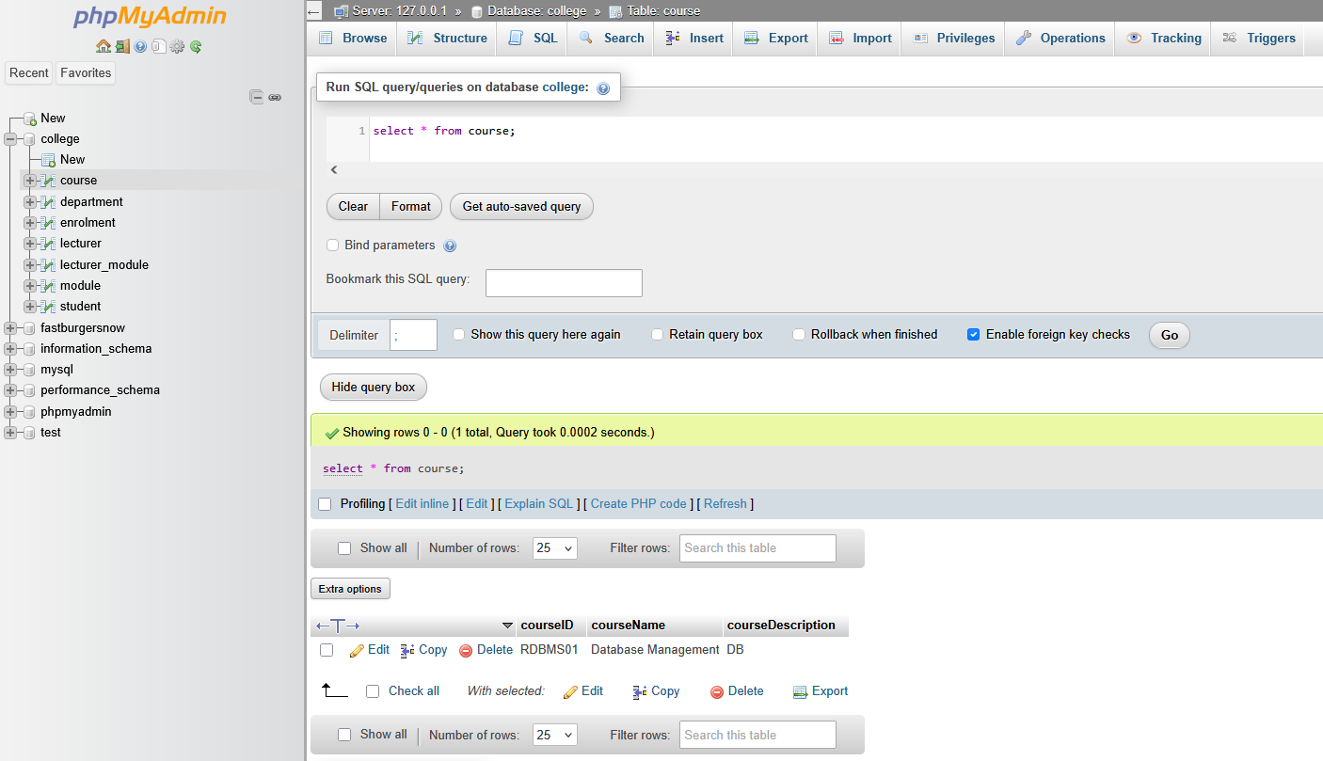

Figure 1 – Query of the course table

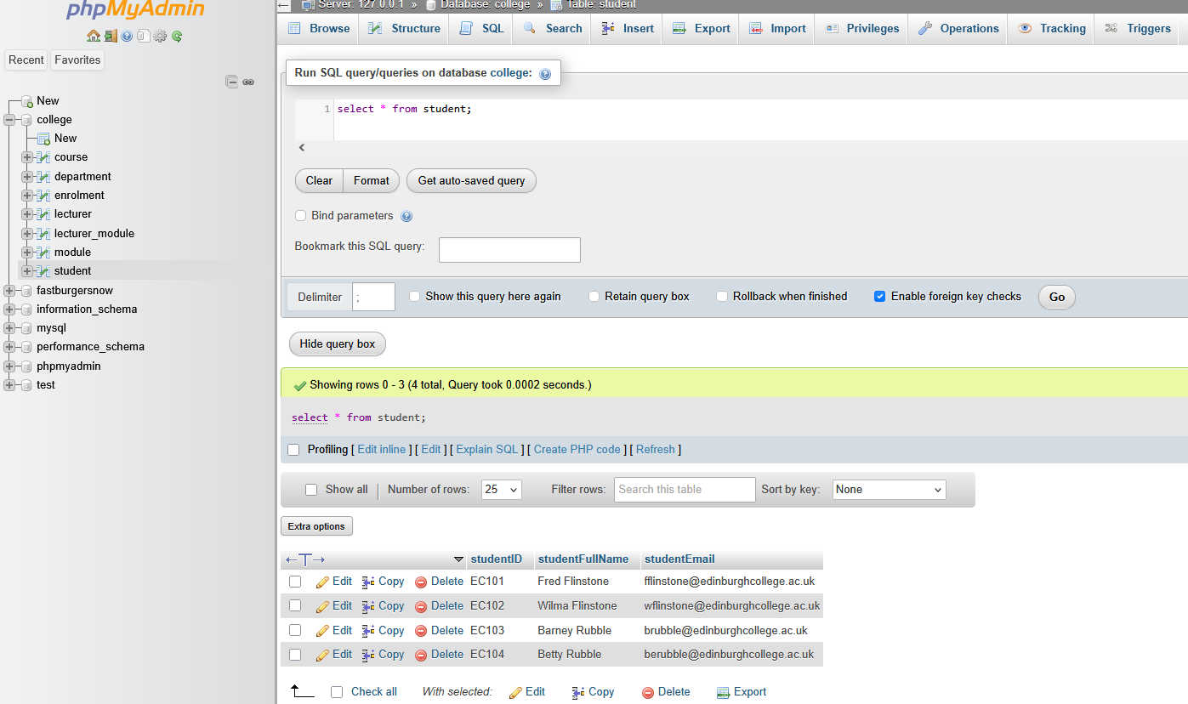

Figure 2 – Query of the student table

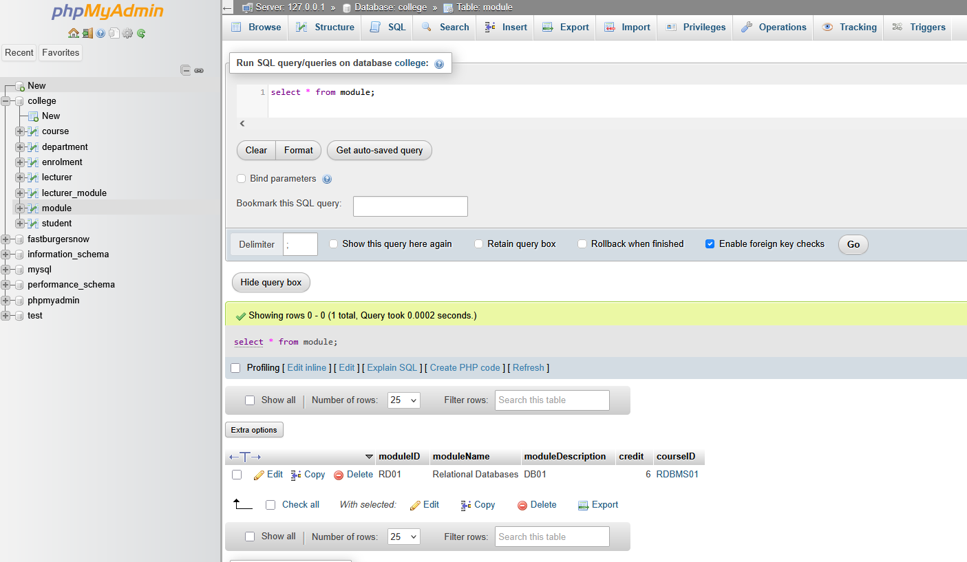

Figure 3 – Query of the module table

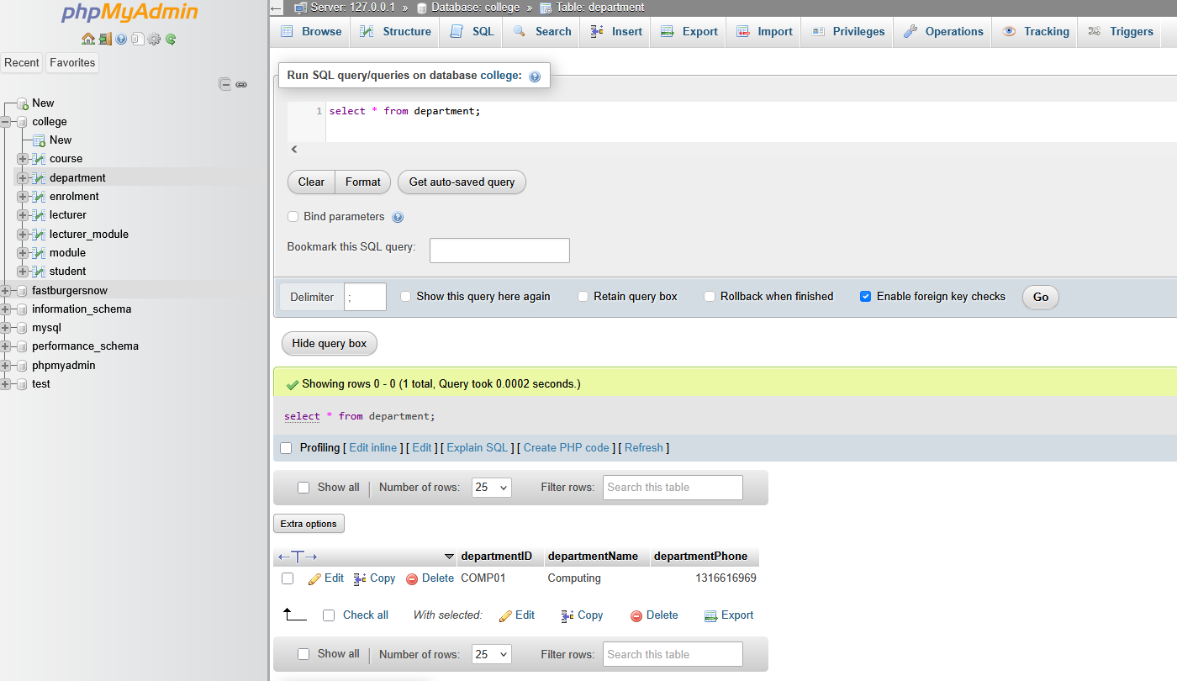

Figure 4 – Query of the department table

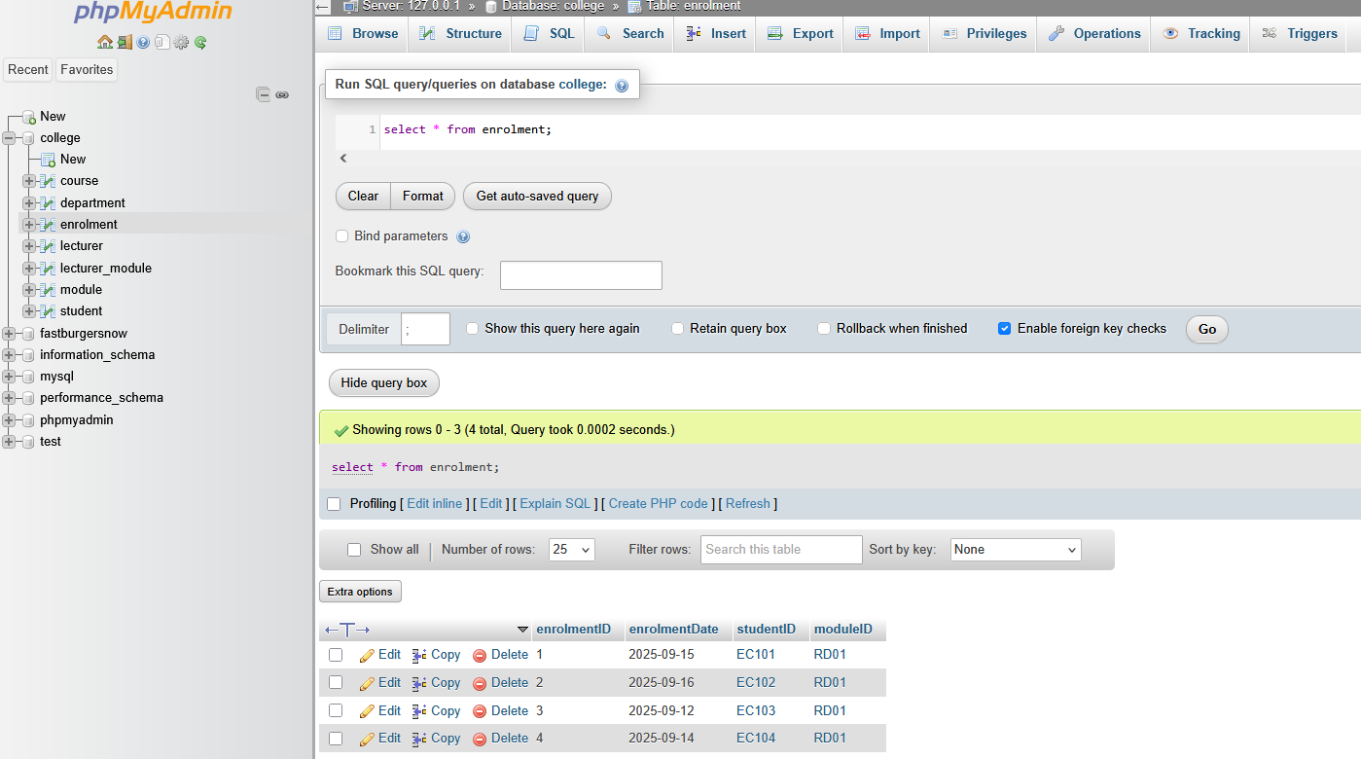

Figure 5 – Query of the enrolment table

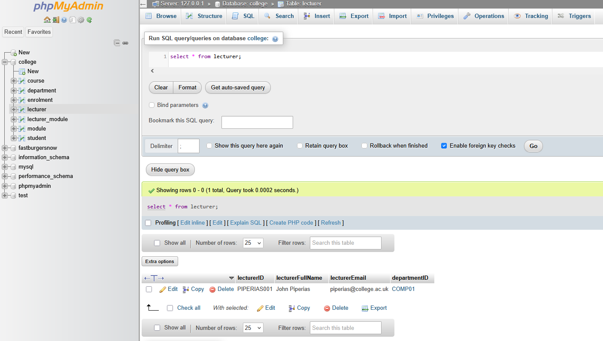

Figure 6 – Query of the lecturer table

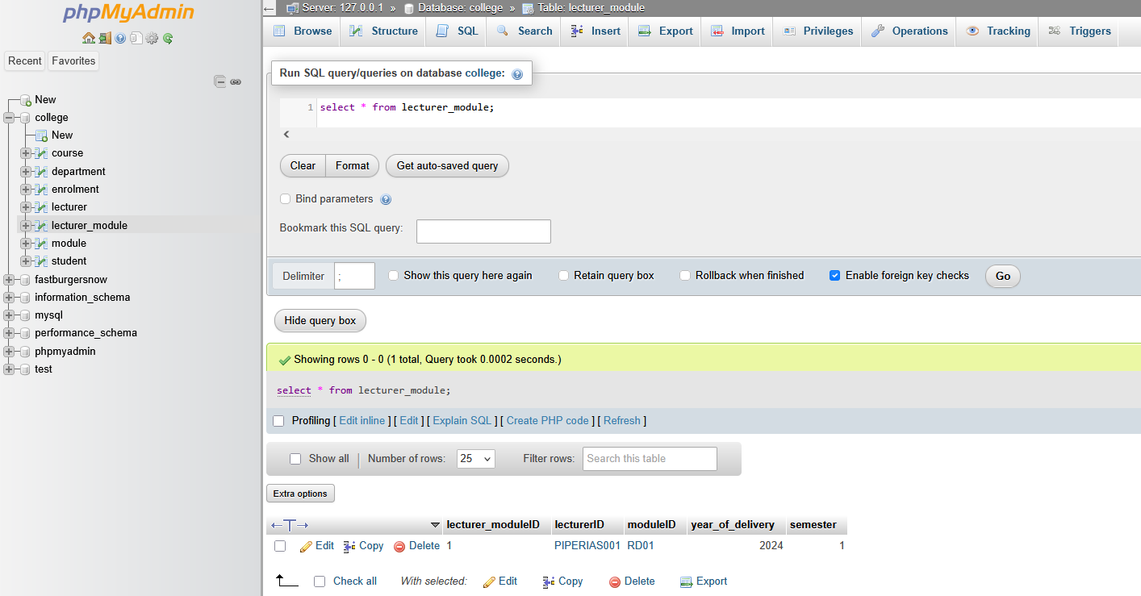

Figure 7 – Query of the lecturer_module table